|  |
| --- |
| Functional Design Document |
| CHG212977 |
| CHG OM: Order management harmonization |
| Markets: e.g. All |
| Release: e.g. RLS000734 (Jun’22) |



Contents

[A. Document approval 3](#_Toc75807726)

[B. Revision history 3](#_Toc75807727)

[1. Business Process Overview 4](#_Toc75807728)

[1.1 Process Overview 4](#_Toc75807729)

[1.2 Impact Matrix 4](#_Toc75807730)

[2. Description of the functional change 5](#_Toc75807731)

[2.1 Changes in Siebel Sales 5](#_Toc75807732)

[2.2 English Captions 5](#_Toc75807733)

[2.3 Changes in the ETL 5](#_Toc75807734)

[2.3.1 Initial Loads/Massive Data updates 6](#_Toc75807735)

[2.3.2 Performance test/Indexes creation 6](#_Toc75807736)

[2.4 Changes in OBI 6](#_Toc75807737)

[2.5 Data Dictionary 7](#_Toc75807738)

[2.6 Changes in Data Interfaces 7](#_Toc75807739)

[2.6.1 Inbound 7](#_Toc75807740)

[2.6.2 Outbound 8](#_Toc75807741)

[2.6.3. Initial Loads 8](#_Toc75807742)

[2.6.4 Performance test / Indexes creation 8](#_Toc75807743)

[2.7 Changes in Batch Processes / Aggregations / DRP 8](#_Toc75807744)

[2.8 Use Case 8](#_Toc75807745)

# Document approval

*List members from market, DBU, BTS, ODC, GTC and other teams that are accountable and responsible for the CHG implementation. Add extra rows if required to include extra team members (e.g. responsible for different areas or services).*

|  |  |  |
| --- | --- | --- |
| Role | Name | Function |
| **Market Sponsor** |  |  |
| **DBU Approver** | Nikita Ryzhkovich | Digital Customer Experience |
| **BTS expert** | Alexander Polyakov | BTS TME Manager |
| **ODC expert** | David Gallego | ODC Sales |
| **ODC expert** | Fran / Migual Lopez | ODC Data |
| **GTC expert** | Jose Carlos Martin | TME Tech Arch Mgr |

This is to confirm that we have reviewed the functional specifications for the proposed solution. We agree with its contents and understand that the technical specifications will be designed based on this approved document.

# Revision history

|  |  |  |  |  |
| --- | --- | --- | --- | --- |
| Revision | Section(s) | Description | Editor | Date |
| 1.0 | 1.1 | Business Process updated | J.Andreyeva | 03.03.2022 |
| 1.1 | All |  | Sahima Murguia | 15.03.2022 |
|  |  |  |  |  |
|  |  |  |  |  |
|  |  |  |  |  |
|  |  |  |  |  |
|  |  |  |  |  |

# Business Process Overview

## Process Overview

With the implementation of TME Connect Reset we want to achieve standardization of the processes, for which assessment of attributes Markets usage has been performed, and so identified those attributes considered part of the Global definition.

This standardization provides the baseline of those attributes required in the BI solution, as well as those that could be used in the new Mobile App.

With this CHG there are additional attributes to be included according to V2/V3 product versions. They must be included as well on the Siebel layouts and in the account inbound interface.

* Inclusion of Mobile Created and Mobile Created By records, to distinguish when record was created in mobile app vs. synched record for Orders and Inventory
* Inclusion of Order Category in Product Template, this will support filtering of the relevant templates according to category in the relevant module
* Inclusion of Promotion Program ID in Material Orders, in order to link the Material Order with the Promotion Program (without the need to generate a Promotion record).

Objective of this CHG is to get the changes applicable for the markets only when each market is rolled to TME Connect Reset. Rest of markets must remain without any impact and working as usually.

However, this CHG is not breaking existing functionality.

The process adaptation for Ireland and Kazakhstan Markets affect Orders, Price list, and Product Templates.

Additionally, missing items identified during Feb’22 release have been included.

We still clarify with Ireland if Link between Sales Order and Legal Entity should be done during Jun’22 release.

~~There are several objects related to OM the attributes are taken from harmonization [table](https://jticorp.sharepoint.com/:x:/r/sites/FutureCRM/Shared%20Documents/Functional%20-%20Global%20Coordination/Global%20Areas/01.%20Global%20Data%20Model/IP20/IP20_Attributes_Harmonization.xlsx?d=w6c1a806ec31540db8c3d62b25be4f26c&csf=1&web=1&e=XvIi6f):~~

* ~~product template;~~
* ~~Inventory location;~~
* ~~order Attachments;~~
* ~~service order;~~
* ~~cycle counting;~~
* ~~payments (Belgium – CME Payments, UK Interim payments);~~
* ~~invoice;~~
* ~~price list.~~

## Impact Matrix

|  |  |
| --- | --- |
| GRM Functionality | Order |
| Impact Current Functionality? | Yes |
| Markets Affected | All |
| Applications Affected | Sales / Data / BI |
| Risk of Implementing the change | Medium |

# Description of the functional change

## Changes in Siebel Sales

Same features implemented during Feb’22 Release related to Order Management must be enabled for V2 and V3 Markets (Ireland and Kazakhstan).

**1.** Service order view: Applets: Applet[0]: JTI Order Entry - Order List Applet (Service); Applet[1]: JTI Order Entry - Order Form Applet (Service); Business Components: BusComp[0]: Order Entry - Orders; BusComp[1]: Order Entry - Orders;

Please use functional designs from following changes:

**Stock request, [CHG212944](https://jti.service-now.com/nav_to.do?uri=change_request.do?sys_id=c80f4fc0dbddf450139ef3a4329619b6)**

**Stock receive, [CHG212943](https://jti.service-now.com/nav_to.do?uri=change_request.do?sys_id=535c03ccdb9df450139ef3a43296198b)**

**Stock Return, [CHG212982](https://jti.service-now.com/nav_to.do?uri=change_request.do?sys_id=9c3e7910dbd1f010e290f3a4329619d8)**

**2.** Pricing Administration view/ Price list: Applets: Applet[0]: Price List Applet; Applet[1]: Price List Form Applet – Child; Business Components: BusComp[0]: Price List; BusComp[1]: Price List;

Please use functional designs from following change: **Price list enhancement, [CHG212936](https://jti.service-now.com/nav_to.do?uri=change_request.do?sys_id=81b1eac8db59f450139ef3a4329619d6)**

**3.**Administration data view/ Template: Applets: Applet[0]: Product Template List Applet; Applet[1]: Product Template Item List Applet; Business Components: Template Header; BusComp[1]: Template Item;

Please use functional designs from following change: **Product templates, [CHG212899](https://jti.service-now.com/nav_to.do?uri=change_request.do?sys_id=fed975041b997090e5ac9825bb4bcbd4)**

* The new order type should be added for selection in the ‘Order Type’ field for product template:

|  |  |  |  |  |  |  |
| --- | --- | --- | --- | --- | --- | --- |
| Type | Display | LIC | Parent LIC | Language | Organization | Note |
| JTI\_SUBTYPE\_TYPE | Stock Request | Stock Request |  | ENU | EIR  English-Ireland | Column ‘High’ should be set to ‘Service’ value for the corresponding new LOV created |

**4.** UOM conversion activation is needed only for Ireland market. (CHG212979: TMEC: OM-Transfer- Shopping Cart: UOM conversion)

**4. Bugs from V1**

**4.1** Don’t see the Material Orders view (bug33652).

Test user: CSTTMECCIT

The Material Orders modules was not active for the testing user, and so it was not possible to validate whether functionality is properly applied for the Market. The views were added to TMEC Global Responsibility for symbolic string validation during Feb’22 release.

As was discussed during V1 the configuration should be updated in June’22 Release. There are details: two changes were created

[CHG227177](https://jti.service-now.com/nav_to.do?uri=change_request.do%3Fsys_id=87621ef3db41c1d0ee3fbaf6f49619ab%26sysparm_stack=change_request_list.do%3Fsysparm_query=active=true" \o "https://jti.service-now.com/nav_to.do?uri=change_request.do%3fsys_id=87621ef3db41c1d0ee3fbaf6f49619ab%26sysparm_stack=change_request_list.do%3fsysparm_query=active=true" \t "_blank):

Title: **TMEC Mobile App - Material Oders / new promo module – Italy**

[CHG227175](https://jti.service-now.com/nav_to.do?uri=change_request.do%3Fsys_id=f7125a73db41c1d0ee3fbaf6f4961972%26sysparm_stack=change_request_list.do%3Fsysparm_query=active=true" \o "https://jti.service-now.com/nav_to.do?uri=change_request.do%3fsys_id=f7125a73db41c1d0ee3fbaf6f4961972%26sysparm_stack=change_request_list.do%3fsysparm_query=active=true" \t "_blank):

Title: **TMEC Mobile App - Material Oders / new promo module – Czech**

[DMND0009665](https://jti.service-now.com/nav_to.do?uri=%2Fdmn_demand.do%3Fsys_id%3D8d0402cf8712455440f132a30cbb3575%26sysparm_domain%3Dnull%26sysparm_domain_scope%3Dnull%26sysparm_record_list%3Dopened_byDYNAMIC90d1921e5f510100a9ad2572f2b477fe%255eORu_requestorDYNAMIC90d1921e5f510100a9ad2572f2b477fe%255eORassigned_toDYNAMIC90d1921e5f510100a9ad2572f2b477fe%255eactive%253dtrue%255eORDERBYcmdb_ci_business_app%26sysparm_record_row%3D1%26sysparm_record_rows%3D1%26sysparm_view%3D%26sysparm_view_forced%3Dtrue)

Title: **TMEC Mobile App - Material Oders / new promo module - Kazakhstan**

**4.2** Selection of the Stock Type should only be available for service order type “Stock Return” (33779).

The point is:

The field should be RW for BO users for the stock return service orders with status not equal to Submitted.

The Service Order view is a shared view for all order types, the idea is to make this field RO for all service order types except 'Stock Return'.

Remember this field is hidden by default, and this Order is originated and closed in Mobile app.











































* 1. New Fields (**JTI Mobile Created, JTI Mobile Created By)** to identify creator and creation date for records raised in the mobile app, in the following entities:
  + Orders (Stock Receive, Stock Request, Material Orders, Sales Orders)
  + Stock Counting
  + Stock Counting Items

|  |  |  |  |  |  |
| --- | --- | --- | --- | --- | --- |
| **BC** | **Field** | **Table / MVL** | **Column / Destination Field** | **Type** | **Picklist** |
| **Orders**  Order Entry – Orders | JTI Mobile Created | |  | | --- | | S\_ORDER | | X\_TMEC\_CREATED\_DT | Date Time |  |
| JTI Mobile Created By | |  | | --- | | S\_ORDER | | X\_TMEC\_CREATED\_BY\_ID | ID |  |
| **Stock Counting header**  Cycle Counting | JTI Mobile Created | S\_INVLOC\_CYCCNT | X\_TMEC\_CREATED\_DT | Date Time |  |
| JTI Mobile Created By | S\_INVLOC\_CYCCNT | X\_TMEC\_CREATED\_BY\_ID | ID |  |
| **Stock Counting item**  Cycle Counting Execution | JTI Mobile Created | S\_PROD\_INV\_CNT | X\_TMEC\_CREATED\_DT | ID |  |
| JTI Mobile Created By | S\_PROD\_INV\_CNT | X\_TMEC\_CREATED\_BY\_ID | Date Time |  |

The following fields **“Mobile Created Date”, “Mobile Created By”** should be included into the following screens. Fields **should be read only, and hidden by default.**

* Material Orders Screens:

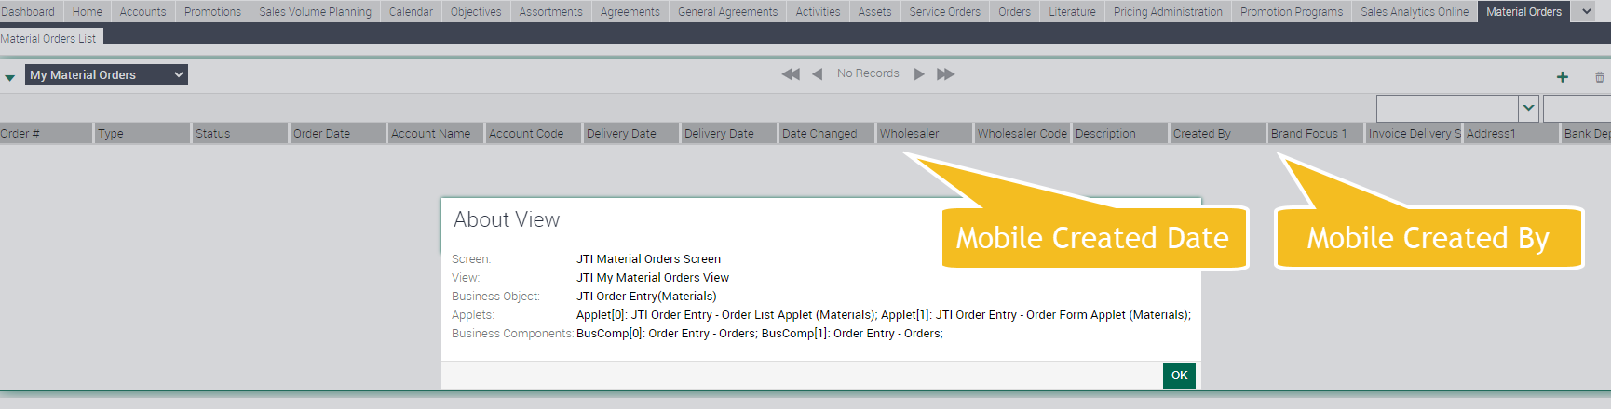

* Service Orders Screens:

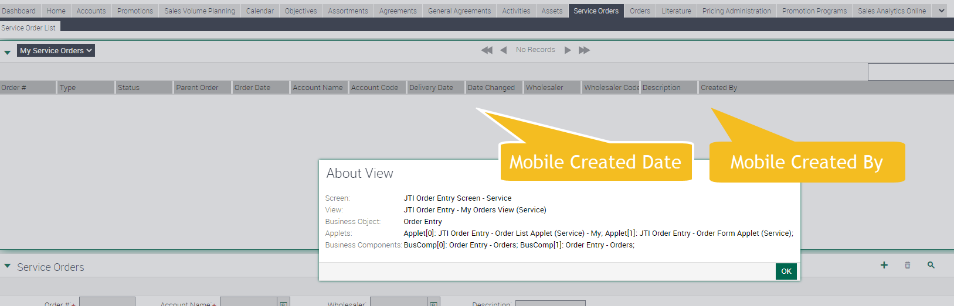

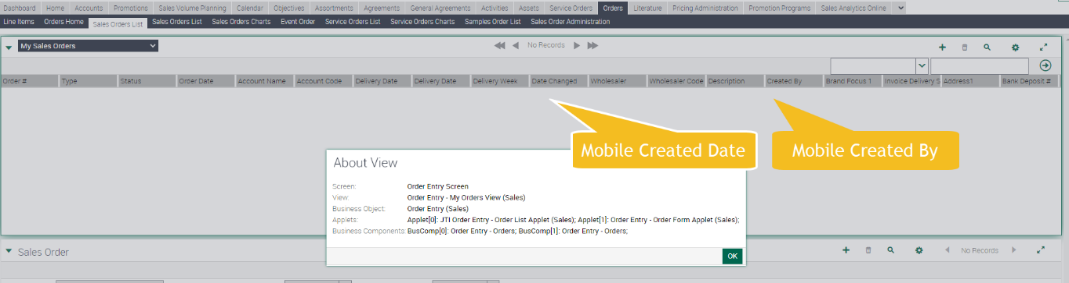

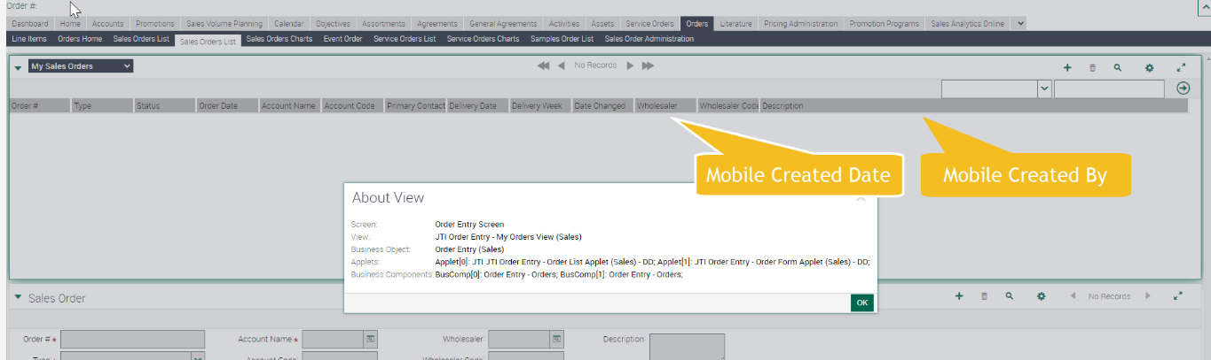

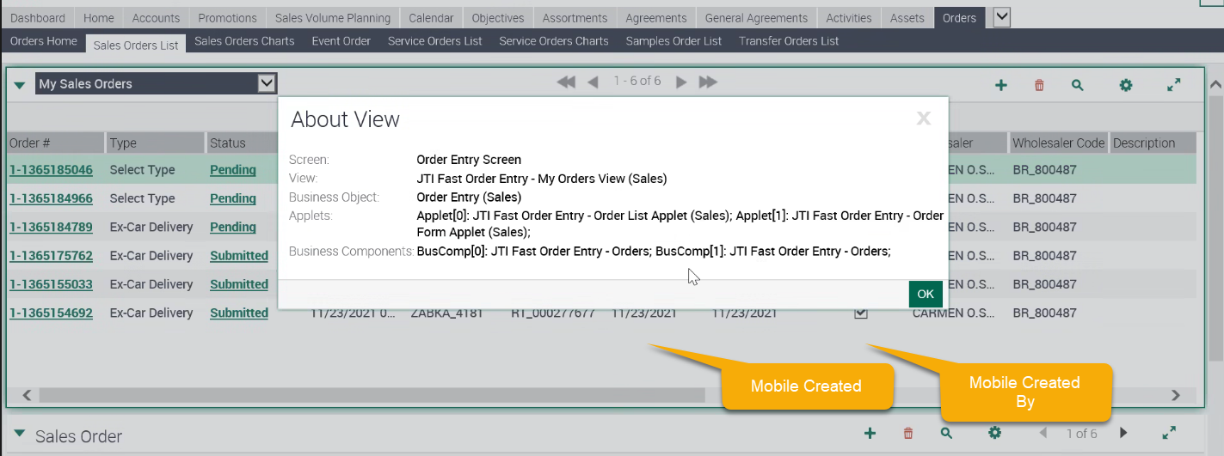

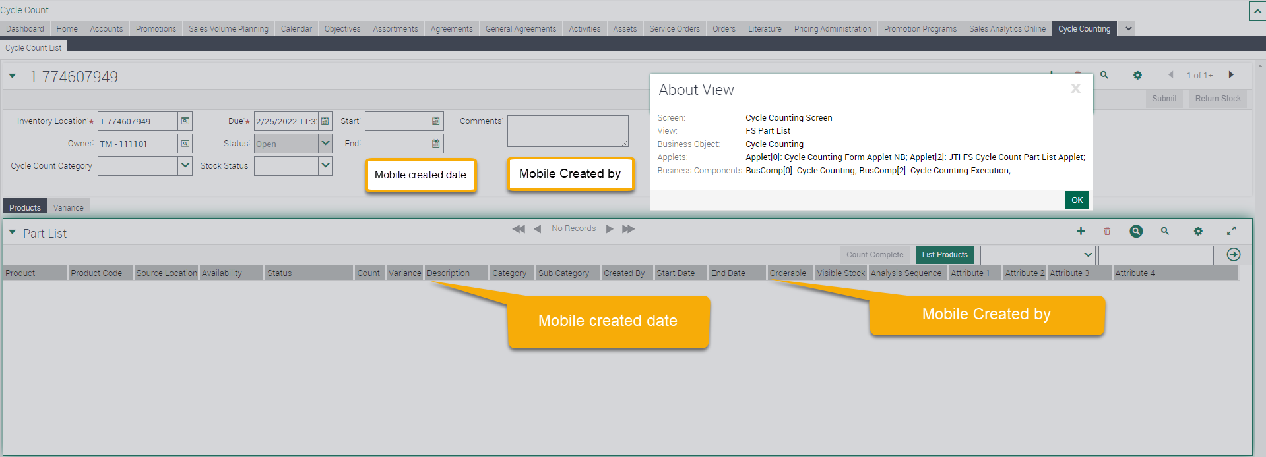

* 1. In order to link the Material Order with the Promotion Program (without the need to generate a Promotion Plan record) it will be needed to incorporate a New field **Promotion Program Id** at Material Order.

|  |  |  |  |  |  |
| --- | --- | --- | --- | --- | --- |
| **BC** | **Field** | **Table / MVL** | **Column / Destination Field** | **Type** | **Picklist** |
| Order Entry - Orders | JTI Promotion Program ID | S\_ORDER | X\_PROMO\_PRG\_ID | ID |  |

* 1. Attribute Order Category should be added to Product Template object:

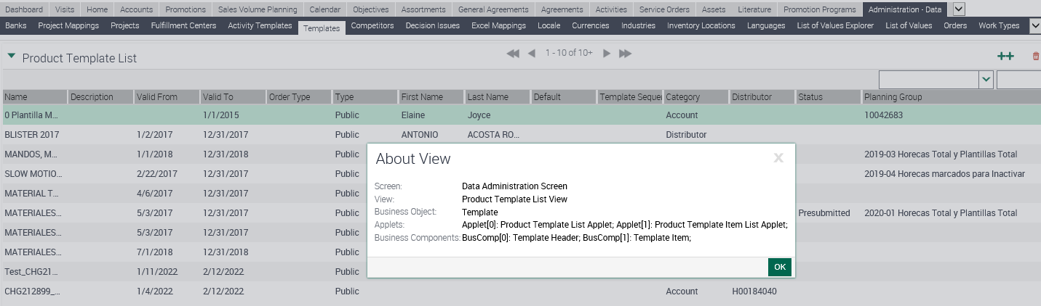

|  |  |  |  |  |  |  |  |
| --- | --- | --- | --- | --- | --- | --- | --- |
| Business Component | Display Value | Attribute | Type | Length | LOV Type | Table | Column |
| Template Header | Order Category | JTI Order Category | Picklist | 30 | JTI\_ORDER\_CATEGORY | S\_DOC\_QUOTE | X\_ORDER\_CTGRY |











## 2.2 English Captions

Stock request

|  |  |  |  |  |
| --- | --- | --- | --- | --- |
| Type | Format | Caption ENU | Language | Caption LOCAL |
| Button |  | Reject | EIR | Reject |
| Field |  | Initially Requested Qty | EIR | Initially Requested Qty |
| Type |  | Stock Request | EIR | Stock Request |
| Field |  | Cancelled Date | EIR | Cancelled Date |
| JTI Mobile Created | DateTime | Mobile Created | ENU | Mobile Created |
| JTI Mobile Created | DateTime | Mobile Created | KZA | Mobile Created |
| JTI Mobile Created By | Text | Mobile Created By | ENU | Mobile Created By |
| JTI Mobile Created By | Text | Mobile Created By | KZA | Mobile Created By |
| Button |  | Reject | KZA | Reject |
| Field |  | Initially Requested Qty | KZA | Initially Requested Qty |
| Type |  | Stock Request | KZA | Stock Request |
| Field |  | Cancelled Date | KZA | Cancelled Date |

The specified setup for a Market should not affect the other Markets setup and/or validations.

|  |  |  |  |  |  |
| --- | --- | --- | --- | --- | --- |
| Type | Display | LIC | Parent LIC | Language | Caption LOCAL |
| JTI\_SUBTYPE\_TYPE | Stock Request | Stock Request |  | EIR | Stock Request |
| JTI\_SUBTYPE\_TYPE | Stock Request | Stock Request |  | ENU | Stock Request |
| LOV | Draft | Draft |  | EIR | Draft |
| LOV | Draft | Draft |  | ENU | Draft |
| LOV | Pending | Pending |  | EIR | Pending |
| LOV | Pending | Pending |  | ENU | Pending |
| LOV | To be approved | To be approved |  | EIR | To be approved |
| LOV | To be approved | To be approved |  | ENU | To be approved |
| LOV | Rejected | Rejected |  | EIR | Rejected |
| LOV | Rejected | Rejected |  | ENU | Rejected |
| LOV | Submitted | Submitted |  | EIR | Submitted |
| LOV | Submitted | Submitted |  | ENU | Submitted |
| LOV | Cancelled by BO | Cancelled by BO |  | EIR | Cancelled by BO |
| LOV | Cancelled by BO | Cancelled by BO |  | ENU | Cancelled by BO |
| LOV | Cancelled by TM | Cancelled by TM |  | EIR | Cancelled by TM |
| LOV | Cancelled by TM | Cancelled by TM |  | ENU | Cancelled by TM |
| LOV | Received | Received |  | EIR | Received |
| LOV | Received | Received |  | ENU | Received |
| LOV | Draft | Draft |  | KZA | Draft |
| LOV | Draft | Draft |  | ENU | Draft |
| LOV | Pending | Pending |  | KZA | Pending |
| LOV | Pending | Pending |  | ENU | Pending |
| LOV | To be approved | To be approved |  | KZA | To be approved |
| LOV | To be approved | To be approved |  | ENU | To be approved |
| LOV | Rejected | Rejected |  | KZA | Rejected |
| LOV | Rejected | Rejected |  | ENU | Rejected |
| LOV | Submitted | Submitted |  | KZA | Submitted |
| LOV | Submitted | Submitted |  | ENU | Submitted |
| LOV | Cancelled by BO | Cancelled by BO |  | KZA | Cancelled by BO |
| LOV | Cancelled by BO | Cancelled by BO |  | ENU | Cancelled by BO |
| LOV | Cancelled by TM | Cancelled by TM |  | KZA | Cancelled by TM |
| LOV | Cancelled by TM | Cancelled by TM |  | ENU | Cancelled by TM |
| LOV | Received | Received |  | KZA | Received |
| LOV | Received | Received |  | ENU | Received |

**Stock receive**

|  |  |  |  |  |
| --- | --- | --- | --- | --- |
| Type | Format | Caption ENU | Language | Caption LOCAL |
| Button |  | Submit | EIR | Submit |
| Button |  | Submit | ENU | Submit |
| Button |  | Submit | KZA | Submit |
| Button |  | Submit | ENU | Submit |

|  |  |  |  |  |  |
| --- | --- | --- | --- | --- | --- |
| Type | Display | LIC | Parent LIC | Language | Caption LOCAL |
| JTI\_SUBTYPE\_TYPE | Stock Receive | Stock Receive |  | EIR | Stock Receive |
| JTI\_SUBTYPE\_TYPE | Stock Receive | Stock Receive |  | ENU | Stock Receive |
| LOV | Pending | Pending |  | EIR | Pending |
| LOV | Pending | Pending |  | ENU | Pending |
| LOV | Rejected | Rejected |  | EIR | Rejected |
| LOV | Rejected | Rejected |  | ENU | Rejected |
| LOV | Submitted | Submitted |  | EIR | Submitted |
| LOV | Submitted | Submitted |  | ENU | Submitted |
| LOV | Cancelled | Cancelled |  | EIR | Cancelled |
| LOV | Cancelled | Cancelled |  | ENU | Cancelled |
| LOV | Received | Received |  | EIR | Received |
| LOV | Received | Received |  | ENU | Received |
| LOV | Pending | Pending |  | KZA | Pending |
| LOV | Pending | Pending |  | ENU | Pending |
| LOV | Rejected | Rejected |  | KZA | Rejected |
| LOV | Rejected | Rejected |  | ENU | Rejected |
| LOV | Submitted | Submitted |  | KZA | Submitted |
| LOV | Submitted | Submitted |  | ENU | Submitted |
| LOV | Cancelled | Cancelled |  | KZA | Cancelled |
| LOV | Cancelled | Cancelled |  | ENU | Cancelled |
| LOV | Received | Received |  | KZA | Received |
| LOV | Received | Received |  | ENU | Received |

**Stock Return**

|  |  |  |  |  |
| --- | --- | --- | --- | --- |
| Type | Format | Caption ENU | Language | Caption LOCAL |
| Field |  | Stock Type | EIR | Stock Type |
| Field |  | Stock Type | ENU | Stock Type |
| Field |  | Stock Type | KZA | Stock Type |
| Field |  | Stock Type | ENU | Stock Type |

|  |  |  |  |  |  |
| --- | --- | --- | --- | --- | --- |
| Type | Display | LIC | Parent LIC | Language | Caption LOCAL |
| JTI\_SUBTYPE\_TYPE | Stock Return | Stock Return |  | EIR | Stock Return |
| JTI\_SUBTYPE\_TYPE | Stock Return | Stock Return |  | ENU | Stock Return |
| JTI\_STOCK\_TYPE | All | All |  | EIR | All |
| JTI\_STOCK\_TYPE | All | All |  | ENU | All |
| JTI\_STOCK\_TYPE | Available | Available |  | EIR | Available |
| JTI\_STOCK\_TYPE | Available | Available |  | ENU | Available |
| JTI\_STOCK\_TYPE | Blocked | Blocked |  | EIR | Blocked |
| JTI\_STOCK\_TYPE | Blocked | Blocked |  | ENU | Blocked |
| JTI\_SUBTYPE\_TYPE | Stock Return | Stock Return |  | KZA | Stock Return |
| JTI\_SUBTYPE\_TYPE | Stock Return | Stock Return |  | ENU | Stock Return |
| JTI\_STOCK\_TYPE | All | All |  | KZA | All |
| JTI\_STOCK\_TYPE | All | All |  | ENU | All |
| JTI\_STOCK\_TYPE | Available | Available |  | KZA | Available |
| JTI\_STOCK\_TYPE | Available | Available |  | ENU | Available |
| JTI\_STOCK\_TYPE | Blocked | Blocked |  | KZA | Blocked |
| JTI\_STOCK\_TYPE | Blocked | Blocked |  | ENU | Blocked |

**Price list**

|  |  |  |  |  |
| --- | --- | --- | --- | --- |
| Type | Format | Caption ENU | Language | Caption LOCAL EIR |
| Field |  | Category | EIR | Category |
| Field |  | Category | ENU | Category |
| Field |  | Target List | EIR | Target List |
| Field |  | Target List | ENU | Target List |
| Field |  | Distributor | EIR | Distributor |
| Field |  | Distributor | ENU | Distributor |
| Button |  | Apply | EIR | Apply |
| Button |  | Apply | ENU | Apply |
| Button |  | Submit Target List | EIR | Submit Target List |
| Button |  | Submit Target List | ENU | Submit Target List |
| Field |  | Category | KZA | Category |
| Field |  | Category | ENU | Category |
| Field |  | Target List | KZA | Target List |
| Field |  | Target List | ENU | Target List |
| Field |  | Distributor | KZA | Distributor |
| Field |  | Distributor | ENU | Distributor |
| Button |  | Apply | KZA | Apply |
| Button |  | Apply | ENU | Apply |
| Button |  | Submit Target List | KZA | Submit Target List |
| Button |  | Submit Target List | ENU | Submit Target List |

|  |  |  |  |  |  |
| --- | --- | --- | --- | --- | --- |
| Type | Display | LIC | Parent LIC | Language | Caption LOCAL |
| JTI\_PRICELIST\_CATEGORY | Account | Account |  | EIR | Account |
| JTI\_PRICELIST\_CATEGORY | Account | Account |  | ENU | Account |
| JTI\_PRICELIST\_CATEGORY | Distributor | Distributor |  | EIR | Distributor |
| JTI\_PRICELIST\_CATEGORY | Distributor | Distributor |  | ENU | Distributor |
| JTI\_PRICELIST\_CATEGORY | Account | Account |  | KZA | Account |
| JTI\_PRICELIST\_CATEGORY | Account | Account |  | ENU | Account |
| JTI\_PRICELIST\_CATEGORY | Distributor | Distributor |  | KZA | Distributor |
| JTI\_PRICELIST\_CATEGORY | Distributor | Distributor |  | ENU | Distributor |

**Product templates**

|  |  |  |  |  |
| --- | --- | --- | --- | --- |
| Type | Format | Caption ENU | Language | Caption LOCAL EIR |
| Field |  | Category | EIR | Category |
| Field |  | Category | ENU | Category |
| LOV | JTI\_TEMPLATE\_CATEGORY | Account | EIR | Account |
| LOV | JTI\_TEMPLATE\_CATEGORY | Account | ENU | Account |
| LOV | JTI\_TEMPLATE\_CATEGORY | Distributor | EIR | Distributor |
| LOV | JTI\_TEMPLATE\_CATEGORY | Distributor | ENU | Distributor |
| Field |  | Target list | EIR | Target list |
| Field |  | Target list | ENU | Target list |
| Field |  | Distributor | EIR | Distributor |
| Field |  | Distributor | ENU | Distributor |
| Field |  | Additional code | EIR | Additional code |
| Field |  | Additional code | ENU | Additional code |
| Button |  | Apply | EIR | Apply |
| Button |  | Apply | ENU | Apply |
| Button |  | Submit Target List | EIR | Submit Target List |
| Button |  | Submit Target List | ENU | Submit Target List |
| Tab |  | Target accounts | EIR | Target accounts |
| Tab |  | Target accounts | ENU | Target accounts |
| Field |  | Category | KZA | Category |
| Field |  | Category | ENU | Category |
| LOV | JTI\_TEMPLATE\_CATEGORY | Account | KZA | Account |
| LOV | JTI\_TEMPLATE\_CATEGORY | Account | ENU | Account |
| LOV | JTI\_TEMPLATE\_CATEGORY | Distributor | KZA | Distributor |
| LOV | JTI\_TEMPLATE\_CATEGORY | Distributor | ENU | Distributor |
| Field |  | Target list | KZA | Target list |
| Field |  | Target list | ENU | Target list |
| Field |  | Distributor | KZA | Distributor |
| Field |  | Distributor | ENU | Distributor |
| Field |  | Additional code | KZA | Additional code |
| Field |  | Additional code | ENU | Additional code |
| Button |  | Apply | KZA | Apply |
| Button |  | Apply | ENU | Apply |
| Button |  | Submit Target List | KZA | Submit Target List |
| Button |  | Submit Target List | ENU | Submit Target List |

## 2.3 Changes in the ETL

|  |  |  |  |  |  |
| --- | --- | --- | --- | --- | --- |
|  | OLTP Source | | ETL | OLAP Target | |
| # | **Entity** | **Attribute** | **Transformation** | **Entity** | **Attribute** |
| Stock Request | OI | Initially Requested Qty |  | Order Items | Initially Requested Qty |
| Stock Receive | Not applicable | | | | |
| Stock Return | Order | Stock Type |  | Order | Stock Type |
| Price list | New fields Category, Distributor needs to be added to ETL.  Please look at comment above about using target list or planning group as soon as decision will be made the attribute target list or planning group needs to be added in ETL and BI. | | | | |
| Price list header | Category |  | Price list | Category |
| Price list header | Distributor |  | Price list | Distributor |
| Product template | New fields Category, Target List, Distributor, Additional code needs to be added to ETL. The attribute target list needs to be added in ETL and BI. | | | | |
|  | Product Template Header | Category | - | Product Template Header | Category |
|  | Product Template Header | Distributor |  | Product Template Header | Distributor |
|  | Product Template Items | Additional code |  | Product Template Items | Additional code |
| Orders | JTI Promotion Program ID | N/A | Orders | JTI Promotion Program Id | Orders |
|  |  | Mobile Created | To be merged with standard Created Date attribute |  | Mobile Created |
|  |  | Mobile Created By | To be merged with standard Created By attributed |  | Mobile Created By |
| Stock Counting |  | Mobile Created | To be merged with standard Created Date attribute |  | Mobile Created |
|  |  | Mobile Created By | To be merged with standard Created By attributed |  | Mobile Created By |

## Initial Loads/Massive Data updates

Attribute created during Feb’22 Release Order Category should be updated accordingly. Refer to Order Category is not updated for the orders (bug33789).

There should be a process to update empty Order Category field (X\_ORDER\_CAT\_CD) with the values from table below and Order Type (X\_SUB\_TYPE) should be matched with order category **based LOV mapping.**

*(For example: if order for Ireland market has category ‘Transfer Order’(parent LOV) then type (child LOV) should be “Order” or ‘Direct Order’ or ‘EDI Order’ or ‘Pre-Sale, Pre-sale order, Preselling ‘)*. The process should be activated by market.

|  |  |  |  |  |  |
| --- | --- | --- | --- | --- | --- |
| LOV type Order category | | LOV type Order Type | | Market | Comment |
| JTI\_Order\_Category | Transfer Order | JTI\_Subtype\_type | Order | Italy |  |
|  |  |  | Volume Negotiation | Spain |  |
|  |  |  | Order | Czech Republic |  |
|  |  |  | Pre-Sale, Pre-sale order, Preselling | Czech Republic |  |
|  |  |  | Order | Ireland |  |
|  |  |  | Direct Order | Ireland |  |
|  |  |  | EDI Order | Ireland |  |
|  |  |  | Pre-Sale, Pre-sale order, Preselling | Ireland |  |
|  |  |  | Order | Kazakhstan |  |
|  |  |  | Pre-Sale, Pre-sale order, Preselling | Kazakhstan |  |
|  | Ex-car order |  | * - | Italy |  |
|  |  |  | Ex-Car Delivery | Spain |  |
|  |  |  | Ex-Car Delivery | Czech Republic |  |
|  |  |  | Ex-Car Delivery | Ireland |  |
|  |  |  | Ex-Car Delivery | Kazakhstan |  |
|  | Telesales Order |  | Telesales Order | Ireland |  |
|  | Web Order |  | * - | Italy |  |
|  |  |  | * - | Spain |  |
|  |  |  | Web Sales Order | Czech Republic |  |
|  |  |  | Web Sales Order | Ireland |  |
|  |  |  | Web Order | Ireland |  |
|  |  |  | * - | Kazakhstan |  |
|  | Service Order |  | * - | Italy |  |
|  |  |  | Stock Request | Spain |  |
|  |  |  | Stock Receive | Spain |  |
|  |  |  | Stock Return | Spain |  |
|  |  |  | Delegate | Spain |  |
|  |  |  | Delegate FF | Spain |  |
|  |  |  | Dry - Stock | Spain |  |
|  |  |  | FF Delegate | Spain |  |
|  |  |  | Order | Spain |  |
|  |  |  | Returns - Bad | Spain |  |
|  |  |  | Receive | Czech Republic |  |
|  |  |  | * - | Ireland |  |
|  |  |  | Receive | Kazakhstan |  |
|  |  |  | Return FF | Kazakhstan |  |
|  | Return Order |  | * - | Italy |  |
|  |  |  | Return | Spain |  |
|  |  |  | Return | Czech Republic |  |
|  |  |  | Return | Ireland |  |
|  |  |  | Return | Kazakhstan |  |
|  | Exchange Order |  | * - | Italy |  |
|  |  |  | * - | Spain |  |
|  |  |  | Exchange | Czech Republic |  |
|  |  |  | Exchange Current | Czech Republic |  |
|  |  |  | Switch Selling | Czech Republic |  |
|  |  |  | Switch Selling | Kazakhstan |  |
|  |  |  | Exchange | Ireland |  |
|  |  |  | Exchange Current | Ireland |  |
|  |  |  | Swap Order | Ireland |  |
|  |  |  | Switch Selling | Ireland |  |

Please refer to CHG212583 where it’s described usage of the order category in the buying groups.



## Performance test/Indexes creation

Not applicable

## Changes in OBI

For TME Connect, the analytic platform will be Power BI, so changes for the ETL are also related to the PBI transfer instead of OBIEE.

**stock request:** New columns “Initially requested Qty’, ‘Cancelled Date’ must be included on the ETL process to transfer the column to PBI.

**product template:** New dimensions are Category, Target list, Distributor, Additional code. The link of product templates with accounts should be available for usage in reports.

## Data Dictionary

|  |  |
| --- | --- |
| Object | Data Dictionary |
| Stock request: | Please, add next values to the Data Dictionary:   * Service order type - “Stock Request”, drop down list where service order type is defined * Column “Initially Requested Qty”- initially requested stock quantity by TM * Cancelled Date, new column with date |
| Stock receive: | Not applicable |
| Stock return: | Not applicable |
| Price list: | Price list category – defines product prices association – account, distributor or null.  Distributor – it is field where distributor should be specifying. |
| Product template: | Category – it is field that helps group accounts which linked to product template. There are Accounts, Distributor, NULL values the field has.  Target list – it is pick applet field where target list should be specifying.  Distributor – it is pick applet field where distributor should be specifying.  Additional code – field for code of product related to third party company |
| JTI Mobile Created | Date when record was created in mobile app |
| JTI Mobile Created By | User that created record in mobile app |

## Changes in Data Interfaces



## Inbound

**Ireland –** Market could install the new version 4 of OI interface if they want to use updated OI interface.

|  |  |  |  |  |  |
| --- | --- | --- | --- | --- | --- |
| OD | | | | | |
| **#** | **Entity** | **Field Name** | **Contents** | **Data type/format** | **Transformation** |
|  |  |  |  |  |  |

**KZA –** Market could install the new version 4 of OI interface if they want to use updated OI interface.

|  |  |  |  |  |  |
| --- | --- | --- | --- | --- | --- |
| N/A | | | | | |
| **#** | **Entity** | **Field Name** | **Contents** | **Data type/format** | **Transformation** |
|  |  |  |  |  |  |



## Outbound

Not applicable

|  |  |  |  |  |  |
| --- | --- | --- | --- | --- | --- |
| N/A | | | | | |
| **#** | **Entity** | **Field Name** | **Contents** | **Data type/format** | **Transformation** |
|  |  |  |  |  |  |



## Initial Loads

Not applicable

## Performance test / Indexes creation

Not applicable

## Changes in Batch Processes / Aggregations / DRP

|  |  |
| --- | --- |
| **Object** | **Changes** |
| Stock request | Not applicable |
| Stock receive | Not applicable |
| Stock return | Not applicable |
| Price list | Data process should be developed to process the price  lists with status ‘pre-Submitted’ to include all accounts  from the associated planning group to the inter  table on incremental way.  Once processed the status of the price list should be  updated to ‘Processed’.  The process will need to be scheduled outside TME ETL hours (depending on each  environment)  The execution frequency should be every 1 hour. |
| Product Template | Data process should be developed in order to process the product templates with  status ‘pre-Submitted’ to include all accounts from the associated planning group to  1 the inter table on incremental way.  Once processed the status of the price list should be updated to ‘Processed’.  The process will need to be scheduled outside TME ETL hours (depending on each environment)  The execution frequency should be every 1 hour. |

In addition, as generic information, there is general description of a process. Development does not need in scope of this June’22 release: When an order is created in the Mobile app, linked to a **Promotion Program** (Place POSM, Sellout, Giveaways), so that Account Promotion Plan is generated accordingly.

Requirement: When during the ETL process, the new order after synched up to Siebel from the Mobile App with “JTI Promotion Program ID” informed, then process should:

* Generate the Promotion Plan record if it does not exist for the Account (only if Account has material orders).
* Once generated, Promotion ID field will be updated in the order.
* Update Product Quantities, based on current Siebel process.

## Use Cases

**1.1 Stock request**

|  |  |  |
| --- | --- | --- |
| Role | Application | Step |
| Local admin, ASM, OP | Sales online | * BO define new product template * Associate it with new service order type “Request” * Add TMs to the list of users associated to the template |
| Local admin | Sales online | * Check that JTI\_Market\_Settings LOV is switched on for IRELAND market |
| ASM, OP | Sales online | * BO create inventory transactions to allocate the needed list of products with Availability “Reserved” and with status “Good” * Check that only one transaction is generated per product per TM |
| TM | TMEC mobile | * TM creates a stock request * Select “Pickup Date” * Add products using corresponding products template * Add quantities * Check if it is possible to request extra products stock (product qty limitation should be enabled) * Check that after submitted stock by TM stock request has status “Pending” and it couldn’t be updated from mobile by TM * Synchronization |
| ASM, OP | Sales online, Interfaces | * Stock request is reflected as new service order with type “Request” with status “Pending” * Revise service order and change status to “Submitted/Cancelled by BO” * Check that status of the service order can be updated via interfaces OD, OS, SI * Check that column “Initially requested qty” is visible in-service order and has values. |
| TM | TMEC mobile | * Synchronization * Stock request has status “To Receive” * Do update after final qty is being received * Check that once finished stock request status changed to “Submitted”. It should be impossible to update service order anymore * Synchronization |
| Local admin, ASM, OP | Sales online | * The service order has status “Submitted” * inventory transactions should be generated for each product included in the service order to reflect impact on the TM inventory |
| TM | TMEC mobile app | * cancel stock request * the stock request’s status is changed to ‘Cancelled by BO\ Cancelled by TM” * synchronization |
| Local admin, ASM, OP | Sales online | * date is filled in new column Cancelled Date and the service order’s status will be set to ‘Cancelled by BO\ Cancelled by TM”. |

**1.2 Stock receive**

|  |  |  |
| --- | --- | --- |
| Role  *Trade Marketer, ASM, Local Admin…* | Application  *Sales, Analytics, ETL, Batch, Interface* | Step  *Description of the step and its expected output* |
| Back office: PO, ASM, Local Admin, TM | Siebel Sales/OBIEE/TMEC mobile | Navigate to view JTI Order Entity – All Orders View (Service)  Create service order with type “Receive”  Specify inventory location  Add products  Press submit button  Service Order status changes to “Pending”  Do synchronization  Check in TMEC mobile new stock receive with type “Receive” and status “To receive”  Revises receive request  Change status to submitted/Cancelled by TM  Check that the appropriate stock mgmt. transaction has been generated in OLTP  Wait for Nightly ETL. Validate that the field is transferred to OBIEE |

**1.3 Stock return**

|  |  |  |
| --- | --- | --- |
| Role  *Trade Marketer, ASM, Local Admin…* | Application  *Sales, Analytics, ETL, Batch, Interface* | Step  *Description of the step and its expected output* |
| Trade marketer | TMEC mobile app | Open My Inventory – Stock Movement  Create “Stock Return – All” item  Add products to Stock Return  Check that products which TM does not have in van are not available in the list of products in the Stock Return  Correct UOM and returned qty values  Remove one product from Stork Return  Sign the Stock Return  Submit the Stok Return – status is “Pending”  Initiate synchronization |
| Local Administrator, OP, ASM | Siebel Sales/ BI | Check that service order with type “Stock Return” and status “Submitted” comes to Back End  Check that the appropriate stock mgmt. transaction has been generated in OLTP  Wait for Nightly ETL. Validate that the field is transferred to PBI. |

**2 Price list**

|  |  |  |
| --- | --- | --- |
| Role  *Trade Marketer, ASM, Local Admin…* | Application  *Sales, Analytics, ETL, Batch, Interface* | Step  *Description of the step and its expected output* |
| Local Admin  Financial Admin  Back Office User | Siebel Sales/OBIEE/TMEC mobile | Check that LOVs NULL, Accounts, Distributor are available in Category field  Populate the new field type manually or via load through interface  Check that field Distributor is inactive by default  Set type of the price list “Distributor” the field Distributor is available for editing  Add distributor  Check that target List or planning group functionality is enabled for pricing administration  Check that new buttons “Apply” and ‘Submit Target List’ work as expected  Check that new price List Accounts view is present  Observe list of accounts associated to the price list  Check that the appropriate data has been synchronized with mobile app  Check that data was not lost during synchronization  Wait for Nightly ETL. Validate that the field is transferred to OBIEE  Validate price list report |

**3 Product template**

|  |  |  |
| --- | --- | --- |
| Role  *Trade Marketer, ASM, Local Admin…* | Application  *Sales, Analytics, ETL, Batch, Interface* | Step  *Description of the step and its expected output* |
| Back office: PO, ASM, Local Admin, TM | Siebel Sales/OBIEE/TMEC mobile | Navigate to view “Product Template List View”  Check that LOVs NULL, Accounts, Distributor are available in Category field  Populate the new category field manually  load through interface and check data in application  Check that field Distributor is inactive by default  Set type of the product template “Distributor” the field Distributor is available for editing  Add distributor  Add value to field additional code  Check that target List or planning group functionality is enabled for product template administration  If choose LOV ‘account’ then target list field became active for adding target list  Once click on the field, ‘Pick Target List’ applet should appear allowing to select target list  press “Ok” button the chosen target list is visible in target list field  Check that new buttons “Apply” and ‘Submit Target List’ work as expected  Check that new product template Accounts view is present  Observe list of accounts associated to the product template  Check that all data have been synchronized with TMEC mobile  Check that data was not lost during synchronization  Wait for Nightly ETL. Validate that all data are transferred to OBIEE  Validate product template report |

**4 Bugs**

V1 bugs should be checked accordingly scenarios below:

Scenario 1: 4.1: Material Order view

|  |  |  |
| --- | --- | --- |
| Role  *Trade Marketer, ASM, Local Admin…* | Application  *Sales, Analytics, ETL, Batch, Interface* | Step  *Description of the step and its expected output* |
| Trade Marketer  (test user: CSTTMECCIT) | Siebel sales | The view exists in TMEC Global Responsibility.  Material order module is active. |
|  | TMEC mobile app | Material Orders/ new promo module for Italy works as expected |
|  | TMEC mobile app | Material Orders/ new promo module for Czech works as expected |
|  | TMEC mobile app | Material Orders/ new promo module (for place POSM activity) KZ market works as expected |

Scenario 2: 4.2

|  |  |  |
| --- | --- | --- |
| Role  *Trade Marketer, ASM, Local Admin…* | Application  *Sales, Analytics, ETL, Batch, Interface* | Step  *Description of the step and its expected output* |
| Local Administrator | Siebel sales | Stock Type selection is available only for service order type “Stock Return” |
|  |  | The field should be RW for BO users if stock return service order status is not equal to Submitted. |
|  |  | The field should be RO for all service order types except ‘Stock Return’ |
|  | TMEC mobile app | The field should be hidden by default. This order is originated and closed in Mobile app |

Scenario 3: bug 33056 this issue were not reproducible. This test should proof that there is not issue.

|  |  |  |
| --- | --- | --- |
| Role  *Trade Marketer, ASM, Local Admin…* | Application  *Sales, Analytics, ETL, Batch, Interface* | Step  *Description of the step and its expected output* |
| Local Administrator | Siebel Sales | Mandatory Markets Testing EIR |
|  |  | Log into the Sales Application |
|  |  | Navigate to Site Map |
|  |  | Click on Accounts - Admin >> Accounts Administration link: User is directed to Accounts - Admin >> Accounts Administration view. |
|  |  | Fill in the following field: Account Name = CHG212943\_Accnt Account Team = <Add a Trade Marketer to the account > Status = Active Account Type = <select other than Wholesaler> Account Class = Employee Fill in the required fields & Save the record: Record is saved successfully. |
|  |  | Click on Accounts Screen tab and click on Accounts List link: User is navigated to Accounts list view |
|  |  | Query for test account name: Record is retrieved. |
|  |  | Drilldown on Account Name: User is redirected to Accounts >> Outlet Visit view |
|  |  | Click on buying group view tab: User is redirected to Accounts >> Buying Group view |
|  |  | On second applet, click on + button to add a new record: Add Account pick applet popup. |
|  |  | Execute query and select any account of type wholesaler and click on Ok button: Pick applet disappears, and account is added on second applet |
|  |  | Navigate to Site Map: A view with a list of all available screens (responsibility-dependent) will be displayed. |
|  |  | Click on Service Orders and click on Service Orders List link: User is navigated to Service Orders List view |
|  |  | *On the top, Click on the new button to create a new Service Orders, fill in the required fields and save record Account Name = CHG212943\_Accnt Type = Stock Receive (ESN value = 'Recibida de stock': Record is saved Successfully. There is NO error: c*omments: An error is displayed when new button is pressed |
|  |  | Verify that order status = Pending: order status = Pending |
|  |  | Drilldown on the new order: User is navigated to Service Order List > Line Items View |
|  |  | On second applet, click on new button: A new line is created |
|  |  | Click on the product pick applet icon: Pick Product pick applet pops up |
|  |  | Select any product and click on Ok button: Product is displayed on second applet |
|  |  | Set the quantity field to '10' and saved the record: The record is saved successfully |
|  |  | On top applet, click on Submit Button: Order is Submitted, the order status changed to 'To Receive' |
|  |  | Verify that top applet is read only: Top applet is read only |
|  |  | Verify that Line Items applet is read only: Line Items applet is read only |
|  |  | Log out |

Scenario 4: bug 33563 was not reproducible, this test should proof that there is not issue:

|  |  |  |
| --- | --- | --- |
| Role  *Trade Marketer, ASM, Local Admin…* | Application  *Sales, Analytics, ETL, Batch, Interface* | Step  *Description of the step and its expected output* |
| Local Administrator | Siebel Sales | Mandatory Markets Testing EIR |
|  |  | Log into the Sales Application |
|  |  | Navigate to Site Map |
|  |  | Click on Accounts - Admin >> Accounts Administration link: User is directed to Accounts - Admin >> Accounts Administration view. |
|  |  | Fill in the following field: Account Name = CHG212943\_Accnt Account Team = <Add a Trade Marketer to the account > Status = Active Account Type = <select other than Wholesaler> Account Class = Employee Fill in the required fields & Save the record: Record is saved successfully. |
|  |  | Click on Accounts Screen tab and click on Accounts List link: User is navigated to Accounts list view |
|  |  | Query for test account name: Record is retrieved. |
|  |  | Drilldown on Account Name: User is redirected to Accounts >> Outlet Visit view |
|  |  | Click on buying group view tab: User is redirected to Accounts >> Buying Group view |
|  |  | On second applet, click on + button to add a new record: Add Account pick applet popup. |
|  |  | Execute query and select any account of type wholesaler and click on Ok button: Pick applet disappears and account is added on second applet |
|  |  | Navigate to Site Map: A view with a list of all available screens (responsibility-dependent) will be displayed. |
|  |  | Click on Service Orders and click on Service Orders List link: User is navigated to Service Orders List view |
|  |  | On the top, Click on the new button to create a new Service Orders, fill in the required fields and save record Account Name = CHG212943\_Accnt Type = Stock Receive (ESN value = 'Recibida de stock': Record is saved Successfully |
|  |  | Verify that order status = Pending: Verify that order status = Pending |
|  |  | Drilldown on the new order: User is navigated to Service Order List > Line Items View |
|  |  | On second applet, click on new button: A new line is created |
|  |  | Click on the product pick applet icon: Pick Product pick applet pops up |
|  |  | Select any product and click on Ok button: Product is displayed on second applet |
|  |  | Set the quantity field to '10' and saved the record: The record is saved successfully |
|  |  | On top applet, click on Submit Button: Order is Submitted, the order status changed to 'To Receive'  Comments: Error on appears when clicking Submit (Enviar) |
|  |  | Verify that top applet is read only: Top applet is read only |
|  |  | Verify that Line Items applet is read only: Line Items applet is read only |
|  |  | Log out |

Scenario 5: Bug 33655 status is not updated when clicking on ‘Apply’:

|  |  |  |
| --- | --- | --- |
| Role  *Trade Marketer, ASM, Local Admin…* | Application  *Sales, Analytics, ETL, Batch, Interface* | Step  *Description of the step and its expected output* |
| Local Administrator | Siebel Sales | Mandatory Markets Testing EIR |
|  |  | Log into the Sales Application: Credentials are Ok. Logged into application. |
|  |  | Click on Accounts - Admin > Accounts Administration View: User is navigated to Accounts Administration View |
|  |  | On the top applet click on the '+' to create a new Account Name: A new line is created |
|  |  | Navigate to site map |
|  |  | Click on Pricing Administration > Price List View: User is navigated to Pricing Administration > Price List View |
|  |  | On top applet, click on applet menu setting and click on Columns Displayed: Columns Displayed pick applet pops up |
|  |  | On the Available Column section, Verify that the below field has added: Category  The field is displayed in the available column |
|  |  | Move the field from Available Columns to Selected Columns and click on Save button: The field is displayed on the top applet. |
|  |  | On the top applet click on the '+' to create a new Price List Name = CHG212936\_PriceList Effective From = <less than Today()> Effective To = <Greater than Today()>:A new line is created |
|  |  | Verify if the below picklist values are available in the field 'Category': Account Distributor  The values are displayed in the field 'Category' |
|  |  | On the second applet, Verify that the below field is displayed:  Category   * The field is displayed |
|  |  | Verify if the below picklist values are available in the field 'Category': Account Distributor  The values are displayed in the field 'Category' |
|  |  | On the Top Applet, drilldown on the record created at step 8:  User is navigated to Price List > Price List Line Item View |
|  |  | On the top Applet, verify the below fields are displayed : Category Distributor Planning Group: The fields are displayed |
|  |  | Click on Planning Group pick icon: Planning Group pick applet pops up |
|  |  | Select a record and click on Ok button: Pick Planning Group field is populated on the first applet |
|  |  | On the Second Applet, Click on Target Accounts tab: User is navigated to Price List > Target Accounts View |
|  |  | On the first applet verify if the button "Apply" has been added: Button is added |
|  |  | Click on the Apply button, Verify that the status changes to Presubmitted: The status changes to Presubmitted. The issue that status is not updated should not be. |
|  |  | On the Second Applet, query the Account created at step 4: Account is retrieved. |
|  |  | Click on the Commit button: The record is displayed in the third Applet |

Scenario 6 test of Changes in Batch Processes / Aggregations / DRP:

|  |  |  |
| --- | --- | --- |
| Role  *Trade Marketer, ASM, Local Admin…* | Application  *Sales, Analytics, ETL, Batch, Interface* | Step  *Description of the step and its expected output* |
| Local Administrator | Siebel Sales/ Mobile app | Mandatory Markets Testing EIR, KZA, Italy, Spain, Czech republic |
|  |  | - during the ETL process, the new order after synched up to Siebel from the Mobile App with “JTI Promotion Program ID” informed |
|  |  | Process should work as requested:   * Generate the Promotion Plan record if it does not exist for the Account (only if Account has material orders). * Once generated, Promotion ID field will be updated in the order. * Update Product Quantities, based on current Siebel process. |

Scenario 7: Test of CHG212936 TMEC: OM - Pricing & Taxation: Price List Enhancement stake. Note on this item, and ensure testing is done during UAT0.